**LAB - 6**

**AUTO CORRELOGRAM BASED CBIVR SYSTEM**

**PRIYANSHU SHARMA**

**15BCE1282**

1. **Study how the following CBIR engines work**

**Akiwi -** Akiwi uses a huge collection of 22 million images tagged with keywords. From these images, akiwi retrieves those that are visually most similar to the uploaded sample. Based on existing tags, akiwi predicts corresponding keywords for the unknown picture.

This approach works very well, supposing most of the retrieved images have similar content. Nevertheless, if no correlating images can be found in the database, this approach may not provide the desired results. Akiwi was designed in such a way to cope with this problem. With a little assistance from the user, akiwi can focus on the correct content type.

**Chic Engine -** Chic Engine is a search engine that allows you to snap a photo instead of keywords to find clothing of interest to you.Chic Engine is a visual fashion search engine.Chic Engine, matches the shape and color of any image led query you input, either via a image file upload or a hosted image URL

**Image Hunter -** It is right now in the development state and it is being developed by Pattern Application Lab

**Baidu Image Search -** It is Japanese image based search engine and the most important thing about this engine is highly reliable. It matches the shape and color of any image led query you input, either via a image file upload or a hosted image URL

**Yandex Image Search -** It is Russian image based search engine

And it one of the best image search engine after Google image search engine. It has a very huge collection of image.

**Google Image Search -** It is best image search engine and is developed by Google Inc.. We can give the query based on the Keyword and we can almost get the expected image output

**Which one is the best?**

**Google > Yandex > Baidu > Akiwi > Chic Engine > Image Hunter**

1. **Convert the image from RGB to HSV and then back to RGB**

**CODE -**

**ANSWER - 2**

clc

clear all

q = imread('C:\Users\PRIYANSHU SHARMA\Desktop\PRIYANSHU\6 STUDY\MATLAB\LAB 6\1.jpg');

figure, imshow(q)

imtool(q)

%Convert RGB to HSV

h = rgb2hsv(q);

figure, imshow(h)

imtool(h)

%Convert RGB to HSV

m = hsv2rgb(h)

imtool(m)

**RESULT**

**RGB IMAGE**

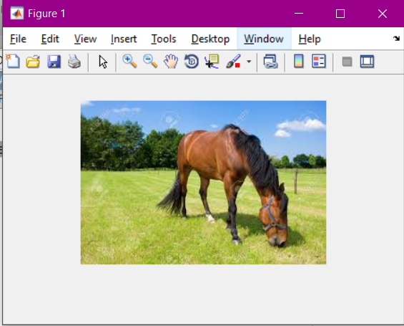

**HSV IMAGE**

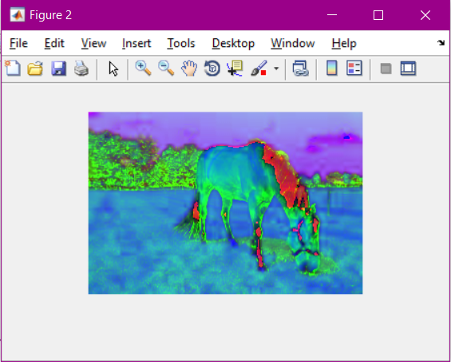

**RGB IMAGE**



**Write the equation for coversion from RGB to HSV and HSV to RGB**

### **RGB to HSV conversion formula**

The *R*,*G*,*B* values are divided by 255 to change the range from 0..255 to 0..1:

*R*' = *R*/255

*G*' = *G*/255

*B*' = *B*/255

*Cmax* = max(*R*', *G*', *B*')

*Cmin* = min(*R*', *G*', *B*')

Δ = *Cmax* - *Cmin*

Hue calculation:

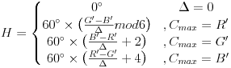

Saturation calculation:

S = { 0, Cmax=0 ;

Δ/Cmax, Cmax!=0}

IMG_257

Value calculation:

*V* = *Cmax*

## **HSV to RGB conversion formula**

When 0 ≤ *H* < 360, 0 ≤ *S* ≤ 1 and 0 ≤ *V* ≤ 1:

*C* = *V* × *S*

*X* = *C* × (1 - |(*H* / 60°) mod 2 - 1|)

*m* = *V* - *C*

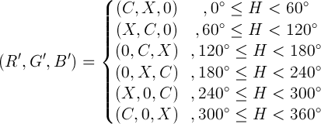

(*R*,*G*,*B*) = ((*R*'+*m*)×255, (*G*'+*m*)×255, (*B*'+*m*)×255)

**Are RGB and HSV values are perceptually same ?**

No, there is the lot of difference between RGB and HSV image. HSV is most common cylindrical-coordinate representation of RGB color model.

**Show the RBG and HSV value of (100,100) pixel**

RGB - [187 199 127]

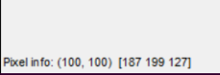

HSV - [0.19 0.36 0.78]

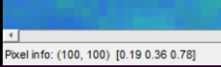

**3. Implement a CBIVR system that derived from Auto Correlogram Descriptors**

**CODE -**

**ANSWER - 3**

clc

clear all

q=imread('C:\Users\PRIYANSHU SHARMA\Desktop\PRIYANSHU\6 STUDY\MATLAB\LAB 6\3.jpg');

%figure, imshow(q)

cv=color\_auto\_correlogram(q,64);

h=imhist(cv,64);

%%DATABASE

fr=[];

srcFiles = dir('C:\Users\PRIYANSHU SHARMA\Desktop\PRIYANSHU\6 STUDY\MATLAB\LAB 6\\*.jpg');

srcFiles;

for i=2:10

d = strcat('C:\Users\PRIYANSHU SHARMA\Desktop\PRIYANSHU\6 STUDY\MATLAB\LAB 6\',srcFiles(i).name);

di = imread(d);

cvd=color\_auto\_correlogram(di,64);

hd=imhist(cvd,64);

%%Manhattan Distance

fr(i) = sum(abs(h-hd));

end

ra=[];

fr(1)=[];

ascen=sort(fr);

[m, n]=size(fr);

k=1;

while(k<n+1)

ex=[];

ex=find(fr==ascen(k));

[q, w]=size(ex);

if(w>1)

for j=1:w

ra(k)=ex(j);

k=k+1;

end

k=k-1;

elseif(w==1)

ra(k)=ex;

end

k=k+1;

end

for i=1:9

name = strcat(num2str(ra(i)),'.jpg');

filename = strcat('C:\Users\PRIYANSHU SHARMA\Desktop\PRIYANSHU\6 STUDY\MATLAB\LAB 6\',name);

result = imread(filename);

figure;

image(result);

end

fr

ascen

ra

**RESULT**

fr = 26 16 0 30 6 14 24 24 22

ascen = 0 6 14 16 22 24 24 26 30

ra = 3 5 6 2 9 7 8 1 4

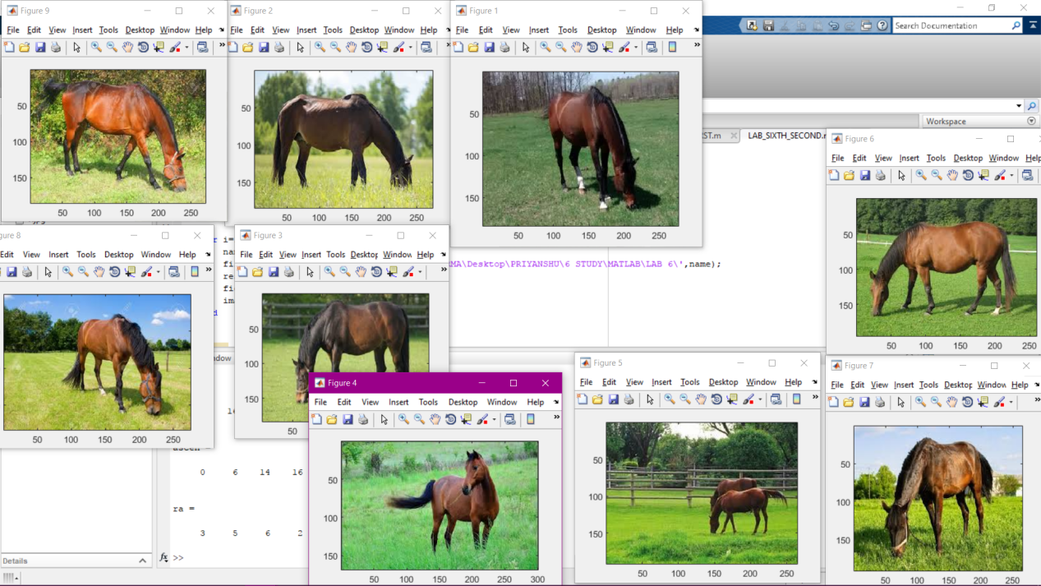

ALL THE RESULTANT IMAGES ARE RETRIEVE FROM THE IMAGE DATABASE